**Steps to Run Application:**

1. Go to git hub [https://github.com/jayagopi1993/](https://github.com/jayagopi1993/Assignment/)
2. Select AngularDev repository.
3. Clone the project Rabobank Angular (Angular project)
4. Run npm install comment and run ng serve commend.
5. Access <http://localhost:4200> url
6. Browse and upload input csv file and output will be displayed in the table
7. Also we can able to search/filter data using filter text box. The values will be filtered based on issuecount column.

Note : please run backend webservice http://127.0.0.1:8081/RobobankCSP/rabobank/extractCSV

**Output:**

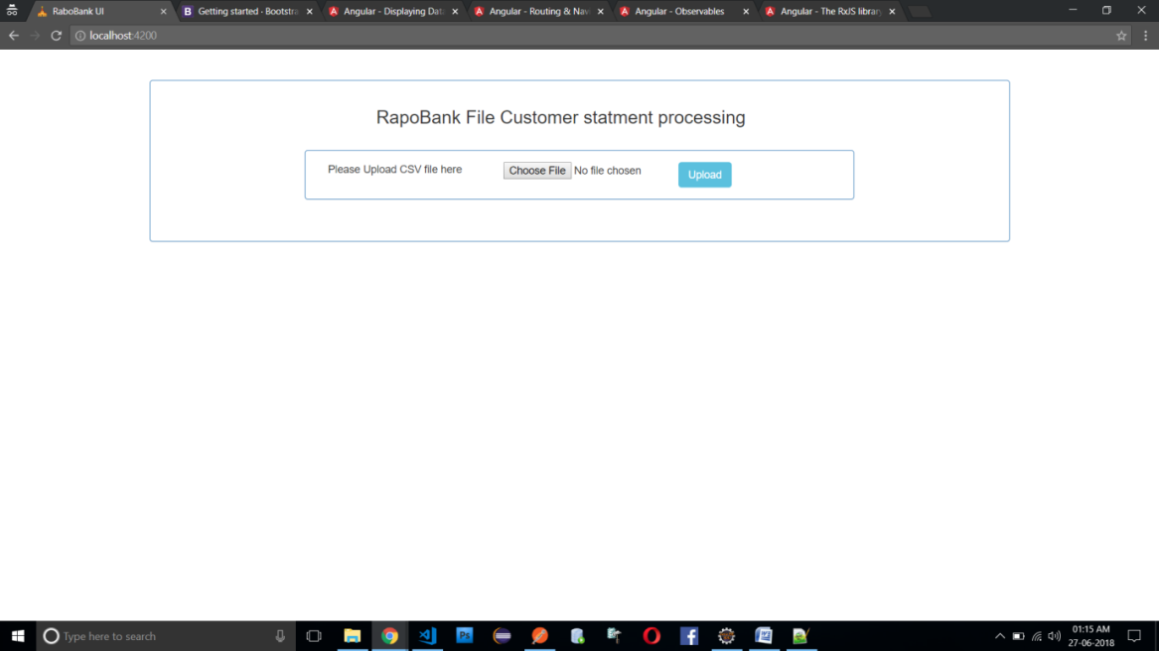

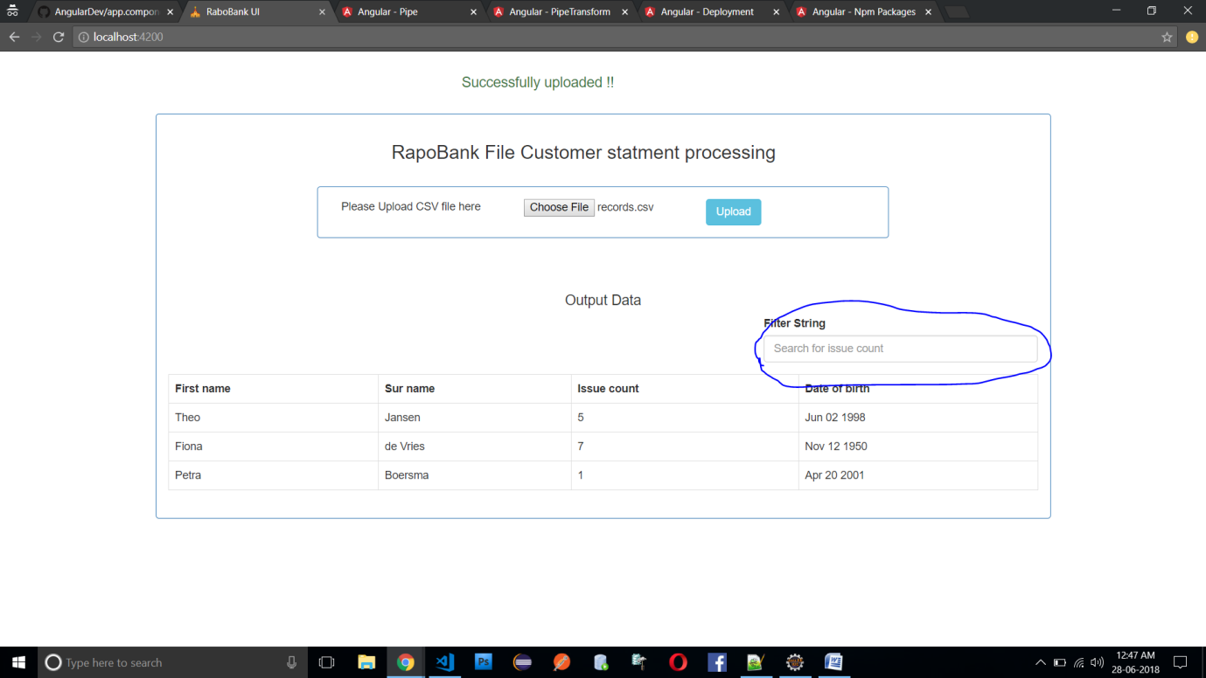

**Input file : record.csv**

**“fname”,”lname”,”issueCount”,”dateOfBirth”**

"Theo","Jansen",5,"Jun 02 1998"

"Fiona","de Vries",7,"Nov 12 1950"

"Petra","Boersma",1,"Apr 20 2001"

**Output of ws: extracted value**

[{

fname : "Theo",

lname: "Jansen",

issueCount : "5",

dateOfBirth : "Jun 02 1998"

},

{

fname : "Fiona",

lname: "de Vries",

issueCount : "7",

dateOfBirth : "Nov 12 1950"

},

{

fname : "Petra",

lname: "Boersma",

issueCount : "1",

dateOfBirth : "Apr 20 2001"

}]